North Country Region
Regional Plan
July 1, 2021 – June 30, 2025

Table of Contents

Table of Contents 1
Regional Service Strategies 2
Sector Initiatives for In-demand Industry Sectors or Occupations 3
Regional Labor Market Analysis 4
Regional Spending Plan 5
Supportive Services 6
Economic Development 6
Performance Accountability Measure Negotiation and Reporting Agreement 7
Public Comment 8

Regional Service Strategies
- Identify regional plan strategies and specifically provide detail on how regional plan strategies relate to the workforce needs of local businesses as well as the priority projects from the Regional Economic Development Council (REDC).
The three North Country Local Workforce Development Boards oversee workforce development activities in seven North Country counties, including:

- Jefferson-Lewis – Jefferson and Lewis counties
- North Country – Clinton, Essex, Franklin, and Hamilton counties
- St. Lawrence – St. Lawrence County

The same seven counties also comprise the seven-county region assigned to the North Country Regional Economic Development Council (NCREDC). This is a congruence between the territory served by both the NCREDC and the three Workforce Development Boards (WDB).

The North County region constitutes approximately 23% of the New York State’s land area and is home to approximately 2.23% of the state’s population. In addition, the region has no population center where economic and workforce activities are focused within the region. Its two most populous cities, Plattsburgh and Watertown – include populations of about 32,901 and 35,505respectively (EMSI April 2021)– are located approximately 160 miles apart; resulting in a three-hour drive from one city to the other (in good weather). Furthermore, about 18% of the region’s population resides in its two major “population centers."

It is important to draw attention to these geographic and demographic realities because they make it difficult to do cohesive regional economic development planning, not to mention workforce planning and delivery, for the seven-county region. The NCREDC has struggled with this issue since its inception in 2011 i.e., how to adopt meaningful strategies that apply to the diverse and extended region and not just to areas where the population clusters are located.

The region’s three Workforce Development Boards (WDBs) are aware of this challenge because all three WDB executive directors are engaged in in the NCREDC, one of them since its implementation. The three directors serve on the NCREDC Workforce Committee and Ms. Mayforth (Jefferson-Lewis) is its co-chair. Additionally, the three executive directors also serve on other NCREDC task forces and work groups. In short, they are aware of the challenges the Council has had.

There are economic commonalities across the region – and the NCREDC has done its best to make the most of them. Dairy farming has a major presence in all but one of the seven counties; tourism is a major factor in all seven counties; and in all but Hamilton County, significant employment is still created by what is left from mines and rural resource-based manufacturing establishments (paper, lumber, dairy products, and transportation).

Notwithstanding this, the differences among the region’s counties – and even within the counties - are dramatic and make it difficult for the seven counties to engage in workforce development planning and implementation activities, even though the executive directors of the region’s three WDBs have been meeting regularly and working together on WIOA and other workforce-related issues.

Most recently, since each WDB’s Local Plan is part of the Regional Plan and since the labor market (see Appendix A) data in the area’s respective Local Plans is regional rather than county specific, the first section of their respective 2021-2024 Local Plans is identical. The executive directors worked with their regional IDAs and economic databases to identify the regional data included.
- Provide a list of executed cooperative agreements where applicable and define how local service providers, including additional providers, will carry out the regional strategies.
The three WDB’s have examined the circumstances of the North Country region and have concluded that using cooperative service delivery agreements is not practical because of the region’s expanse (23% of NYS’ land mass) and the lack of a central community on which the economy and labor market focuses. The three areas cannot envision cooperative service delivery scenarios in which the inefficiencies generated by the region’s geography and demography don’t exceed the efficiencies attained.

NYSDOL recognizes these challenges. It serves the seven-county North Country region from eight offices and only among the three offices located in St. Lawrence County is there significant shared service delivery in place.

Sector Initiatives for In-demand Industry Sectors or Occupations
- Identify in-demand industry sectors and occupations.
As part of the preparation of the three WDB’s respective Local Plans, the region’s three WDB’s developed a common demand occupations list. The list focuses on occupations, not sectors, because of the region’s heterogeneous employer base. For example:

- There are paper mills in four counties, but not in the other three.

- Businesses focusing on supporting Ft. Drum in Jefferson County may also affect portions of neighboring Lewis and St. Lawrence counties but demand for such occupations in the rest of the region is non-existent.

- The four colleges located within 10 miles of each other in central St. Lawrence County create occupational demands whose only close parallel is a two-hour drive in Plattsburgh and Saranac Lake areas (each hosting two colleges). Jefferson Community College is a Liberal Arts College. Delivers the #1 Nursing program in the state.

The list for in demand occupations can be accessed at: http://www.labor.ny.gov/workforcenypartners/lwia/lwia-occs.shtm. It is a testament to the sub-regional differences that characterize the region’s employers’ skills demand but also demonstrates (as noted earlier) the overlapping in occupational demands among the three WDB’s. Examples of the latter include health care professions and tourism.
- Identify and describe sector initiatives that address the needs of the identified in-demand industry sectors or occupations.
The North Country Region has been declared a Childcare desert and the lack of childcare has taken a toll on hiring and contributing to the labor shortages. All three WDB’s and the NCREDC workgroup have been working on strategies. Jefferson-Lewis in partnership with the IDAs, WDB, Small Business Development the Child Care Projects have developed a childcare bootcamp to training possible new providers. St. Lawrence County has a Pipeline group to address the issue and the North Country WDB has the Stand up For Childcare Advocacy Group.
Healthcare continues to be an in-demand sector. The Region has partnered with HMO for the H1B1 rural healthcare training grant.
Tourism & Hospitality: This has been one of the hardest hit area during the pandemic with the loss of workers. The area’s BOCES, colleges and partnerships with the Chambers to promote hiring along with Job Fairs to assist this sector.
Transportation: the need for CDL drivers is in-demand. Through On-The-Job training, programs at SUNY Canton to provide training opportunities.
Manufacturing: The North Country has AIM, RAMP, Namstrams and Authencity STEM, Jefferson-Lewis has BOCES, OJT and St. Lawrence County has BOCES programs

Regional Labor Market Analysis
- Include an analysis of regional economic conditions incorporating the existing emerging demand sectors and occupations, the employment needs of businesses in those sectors and occupations, as well as noting if the information used in the analysis was provided by the New York State Department of Labor’s (NYSDOL) Research and Statistics (R&S) Division (if not, provide what source was used for complete analysis).
The three WDBs have relied on NYSDOL’s North Country regional labor market analyst, Mr. Anthony Hayden, who is based in Lake Placid. He has given his time and expertise and has continued the long-term collaboration between the region’s WDBs which pre-dates the creation of the regional councils.

As noted earlier, the three WDB’s executive directors have collaborated in their use of Mr. Hayden’s data in preparing their respective Local Plans. The four have forged a working collaboration to provide services to the region.

Additionally, the three WDBs have accessed economic development data through EMSI, which gives a timely picture of the economic situation in the region’s seven counties.
- Describe the knowledge, skills and abilities needed to meet the employment needs of businesses in those sectors and occupations.
The North Country Region is home to 7 Colleges and Universities along with excellent Career & Technical training provided at BOCES. In review of KSAs by the WDBs it has been determined that pipelines are in place to take community members from entry level to higher skill levels and provides for career ladders. With excellent partnerships with economic development, businesses and training programs, adjustments are made to meet the needs of local businesses.
- Provide an analysis of the regional workforce.
Appendix A
Labor Market Profile
Resident Civilian Labor and Nonfarm Employment
NORTH COUNTRY REGION
September 2017

Category | Sep 2017 | Net Year | % Year
Resident Civilian Labor Force | 177,100 | 1,100 | 0.6%
Employed | 167,900 | 1,500 | 0.9%
Unemployed | 9,200 | -300 | -3.2%
North Country Region Unemployment Rate | 5.2% | -0.2
NYS Unemployment Rate | 4.7% | -0.2
US Unemployment Rate | 4.1% | -0.7
Total Nonfarm | 160,100 | 1,300 | 0.8%
Total Private | 113,500 | 1,300 | 1.2%
Goods-producing | 17,400 | 300 | 1.8%
Natural Resources, Mining & Construction | 6,900 | 200 | 3.0%
Manufacturing | 10,500 | 100 | 1.0%
Service-Providing | 142,700 | 1,000 | 0.7%
Private Service-Providing | 96,100 | 1,000 | 1.1%
Trade, Transportation & Utilities | 28,600 | 500 | 1.8%
Information | 1,800 | 0 | 0.0%
Financial Activities | 3,700 | 0 | 0.0%
Professional & Business Services | 7,000 | 0 | 0.0%
Education & Health Services | 32,300 | 500 | 1.6%
Leisure & Hospitality | 17,600 | -100 | -0.6%
Other Services | 5,100 | 100 | 2.0%
Government | 46,600 | 0 | 0.0%

Regional Spending Plan
- Include a regional spending plan that includes administrative cost arrangements between LWBDs and the pooling of funds where applicable.
WIOA states the Regional Plan should include “the establishment of administrative cost arrangements, including the pooling of funds for administrative costs, as appropriate, for the region…” As in the case of regional service strategies as stated above, the region’s three WDB’s have examined the circumstances of the North Country region and created a regional spending plan that includes administrative cost arrangements while pooling funds is not appropriate at this time due to factors highlighted above.

Due to differences in the way the three WDB’s deliver services and the variations in the customer base, pooling funds would not address the specific needs of our diverse areas and their populations. A partnership with other WDBs on a rural Health Care Grant.

Supportive Services
- Describe how supportive services will be coordinated throughout the region.
WIOA states the Regional Plan should include “the coordination of transportation and other supportive services, as appropriate, for the region.” As explained above, the three WDB’s have concluded that such coordination is not appropriate due to the vast geographical size of our region and its sparce population. The decentralization of our most populated areas (Plattsburgh and Watertown) further complicates the notion of providing a coordinated transportation or supportive services system.

Economic Development
- Describe how economic development and workforce investment activities will be coordinated in the region and specifically provide detail how continued coordination can further relationships between the region and its respective REDC.
In WIOA, it says the regional plan should include “the coordination of services with regional economic development services and providers.” The three North Country WDBs currently work closely with their local and county-level economic development services and providers.

Though there are many local and county-level development services and providers, there are few that cover the entire region. Aside from the NCREDC, there are only three other regional economic development service providers whose service territory covers the same seven counties of the region as the NCREDC. The three (3) organization are:

- CITEC, Inc., the Regional Technology Development Organization for the region,
- North County Alliance (NCA)
- Workforce Development Institute (WDI)

CITEC provides training for manufacturing clients and all three WDBs use its services when appropriate. Meanwhile, the training CITEC does focuses on upgrade and management training and generally there are fewer opportunities to use WIOA funds for such training because the employees to be trained are ineligible for WIOA assistance. The three WDB’s collaborate with CITEC in other areas.

The NCA is a seven-county economic development organization which started as a trade association of the region’s economic developers in the mid-1980s. Since then, it has expanded its membership to include bank and business membership. Since the NCA has for the last few years been expanding beyond its trade association roots, it is time for the other two North Country WDB’s to join the organization. The executive directors of both the Jefferson-Lewis and North Country WDB’s plan to become members of the NCA shortly.

Lastly, the WDBs also work in close collaboration with WDI as it funds training and education activities such as Manufacturing Day, Business and Education Forum, and Adirondack P-Tech. The WDI also participates in the activities of the NCREDC’s Workforce Committee,

Examples of WDI’s collaboration with the WDBs include:
- The Medical Academy of Science and Health (MASH) Camp in Jefferson and Lewis counties
- Their participation in the Workforce Development Councils in Clinton, Essex, Franklin and Hamilton counties; and
- The WDI’s recent commitment of training funds to help Titan Mining restart the Balmat zinc mine in St. Lawrence County
- WDI has also worked to get Namstrams and USDA grants
- The Jefferson-Lewis WDB Director is the NCREDC Workforce Committee Co-Chair with the WDI North Country representative acting as the other co-chair.

In addition to continuing their collaboration with CITEC, WDI, and the NCA, as well as with their local economic development partners, the three WDBs will continue to work with the NCREDC. As mentioned in the Introduction to this Regional Plan, the three WDB Directors have been involved with the NCREDC. Two of WDB Directors are on the P3IC Committee and all three (3) serve on the NCREDC Workforce Committee. They will continue to serve on these and other appropriate work groups constituted by the Council.

Performance Accountability Measure Negotiation and Reporting Agreement
- Include an agreement concerning the Performance Accountability Measure Negotiation and Reporting. Performance Accountability Measure Negotiation and Reporting may be negotiated by LWDBs individually, involving strategies and methods collaborated on at the regional level. If this is the case for the region, include a statement that reflects that the measures were negotiated individually and any collaborative efforts devised and agreed to by the region.
It is not surprising that the North Country’s three WDB’s are consistent when they say that they have conferred on how they can “collectively negotiate and reach agreement with the Governor on local levels of performance for, and report on, the performance accountability measures described in section 116(c), for local areas or the planning region” and that they determined, given the diversity of the region, the distances and the diffuse labor market, it is not feasible to have common performance accountability measures that apply to the seven counties.

This Local Plan proposes to develop meaningful accountability data in the North Country by continuing to apply the measures to the three WDB’s as is currently the practice. The North Country WDBs choose the WIOA approved option to develop local levels of performance for each of the region’s three (3) local areas and not for the region, as a whole. These performance measures were recently negotiated separately, but in collaboration, in March of 2020.

The three WDB’s will also continue their long-standing practice of conferring about how benchmarks for the new performance standards prescribed by WIOA should be developed and whether there should be symmetry among them as they are applied to the regions’ WDB’s. In spite of the WDB’s insistence that the region is too large, too decentralized, and too diverse to permit them to adopt meaningful regional service strategies, sector initiatives, spending plans, and coordinated support services, the seven counties DO have many things in common when it comes to performance measures.

For key economic benchmarks such as high unemployment, aging workforce, and low household incomes and, in spite of considerable variety across the seven counties, the three WDB’s will continue to consult with each other, recognizing that the region’s counties are intensely rural, and that performance measures and benchmarks designed to fit all regions do not apply fairly or meaningfully to rural counties like those in the North Country.

Public Comment
- Describe the process used by the region to provide a period of no more than 30 days for public comment and input into development of the plan by representatives of business, labor organizations, and education prior to submission.
Each WDB followed policies and procedures for the public comment period and are on file with each office.

North Country Educational Attainment
NORTH COUNTRY REGION
April 2021
Seven County Educational Attainment:
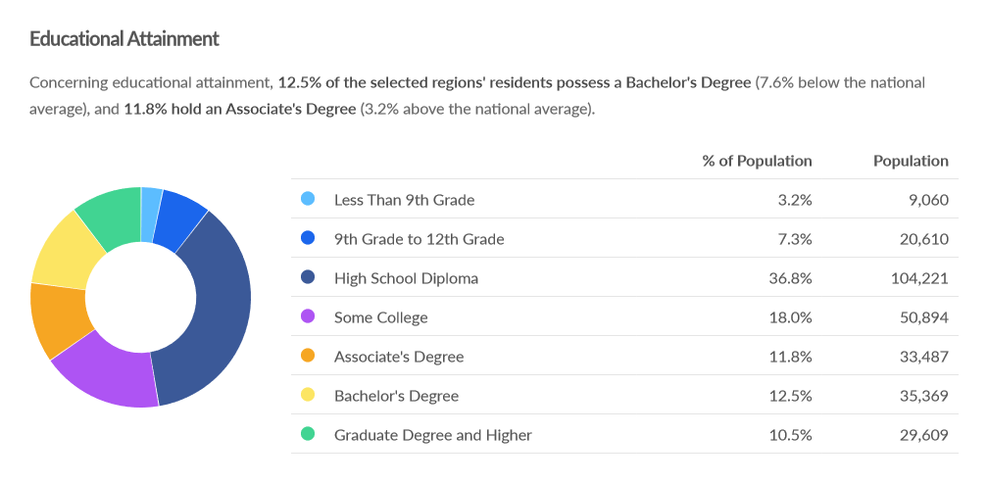
Jefferson-Lewis Workforce Development Board
Jefferson County Educational Attainment:
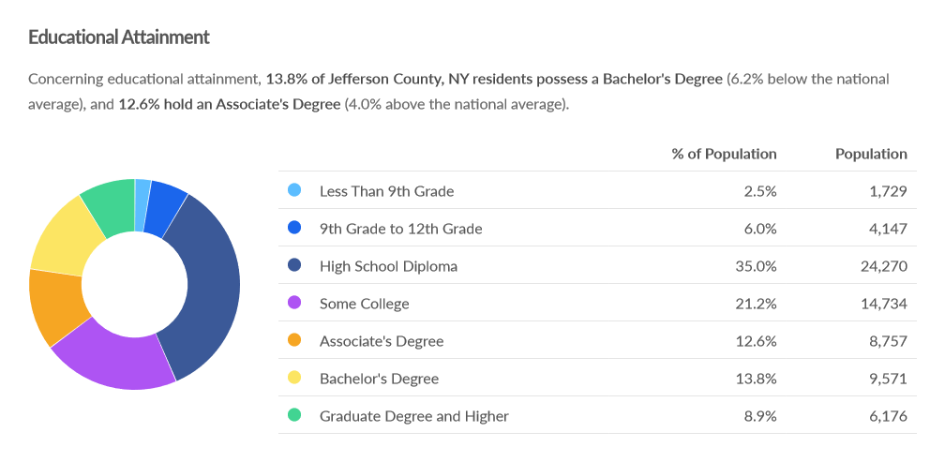
Lewis County Educational Attainment:
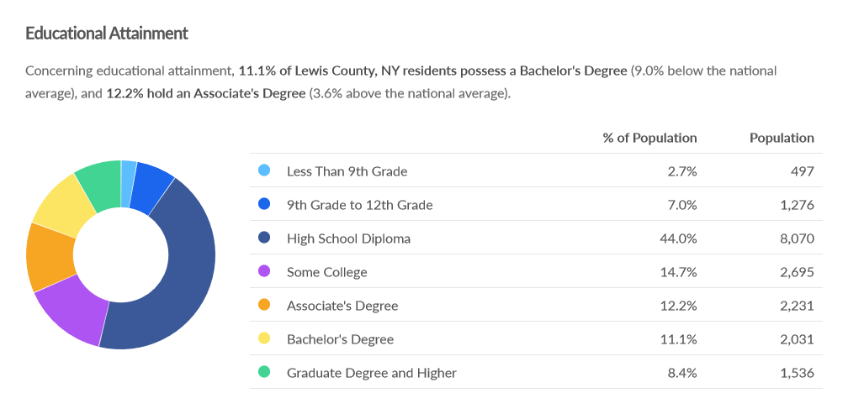
North Country Workforce Development Board
Clinton County Educational Attainment:
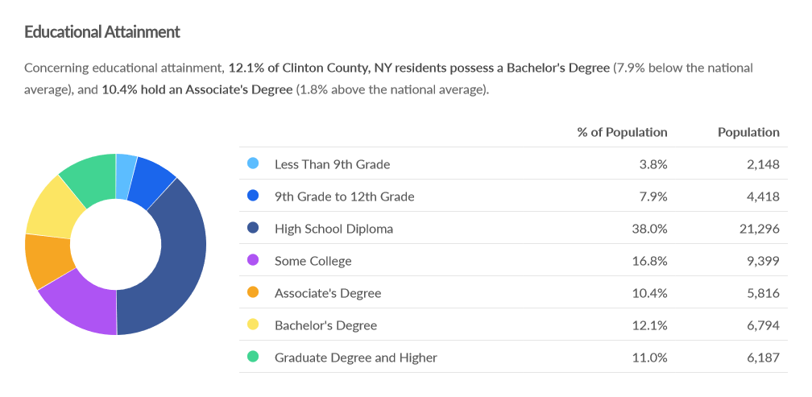

Essex County Educational Attainment:
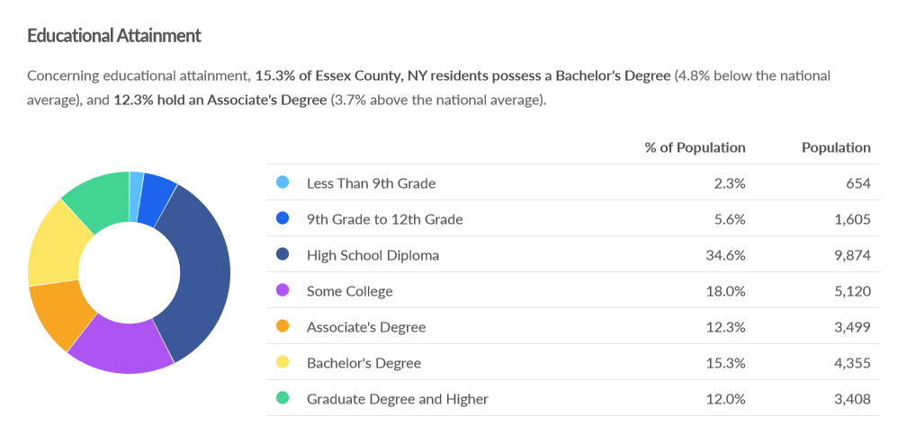
Franklin County Educational Attainment:
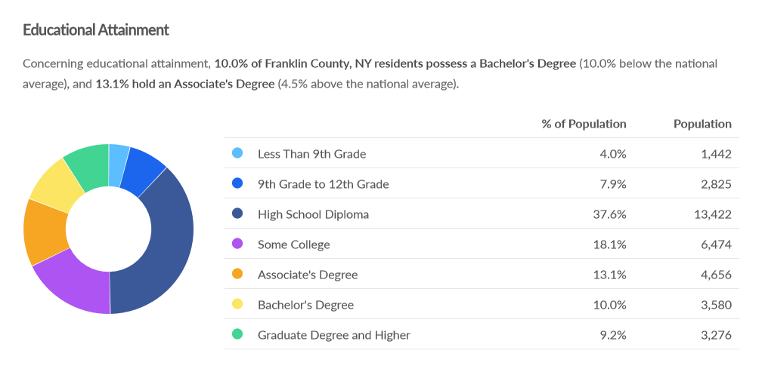

Hamilton County Educational Attainment:
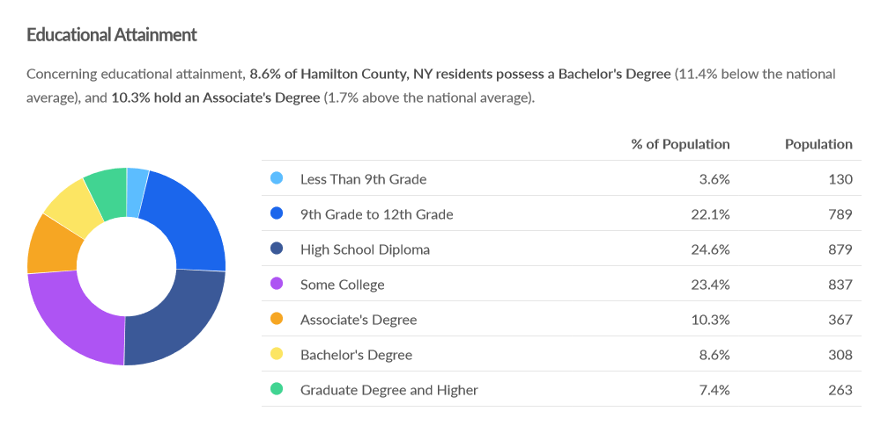
St. Lawrence County Workforce Development Board
St. Lawrence County Educational Attainment:
